AI BUDDY STUDY

Team ID:

SWTID-2026-1732
Team Leader:
Saranya S(C24UG152CSC066)
Team Members:
Kokila R(C24UG152CSCO32)
Nayana M(C24UG152CSC047)
Nethra S(C24UG152CSC048)

LearnMate - AI assistant for smarter learning and study support.

Description

What is it?
AI learning platform where students upload their own notes/PDFs and AI auto-generates Summary, Flashcards, Quiz & Study Plan. Tech: Node.js, Express, MongoDB, JWT + Gemini AI.

Problem (Rahul Case):

Notes scattered, no time to read huge content, manual summary/quiz making waste of time, no study plan, no self-assessment.

Solution:

One centralized app.
Flow: Register/Login (JWT) -> Upload Notes -> Select AI Feature -> Instant Result -> Save for Revision

- Auth Module: JWT + bcrypt
- Storage: MongoDB for users & materials
- AI Module: Gemini API for dynamic content generation
- Admin Module: Manage users & monitor logs

Outcome:

Less manual work, fast revision, personalized learning, scalable modular backend.

Epic 1: Project Architecture

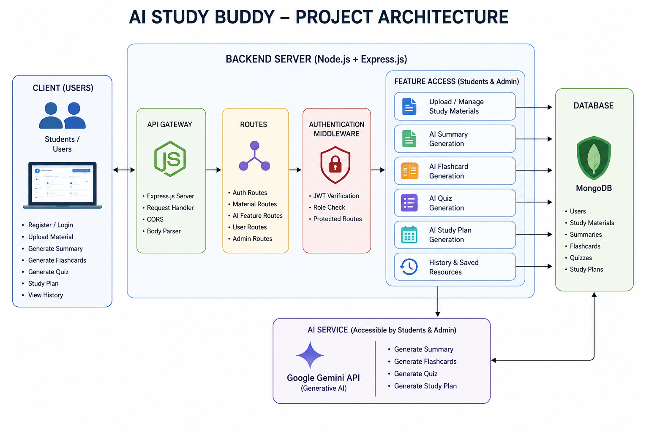

Backend Architecture

Flow:

React Client -> Express Server -> JWT Middleware -> Route Handlers -> [DB Layer / AI Service]

4 Modular Layers:

1. Auth: JWT verification, protects all private & AI routes

2. Business Logic: Route handlers for Auth, Materials, AI, Admin

3. DB Layer: MongoDB + Mongoose - stores users, materials, generated data

4. AI Service: Connects to Gemini API for Summary / Quiz / Flashcards / Study Plan

Components:

- Client (React): UI for register, login, upload, request AI

- Express Server: Core routing & middleware

- Auth Middleware: Validates token before accessing data

- Route Handlers: REST endpoints

- AI Service Layer: Prompt + Content -> Gemini -> Response

- Database Layer: Secure persistent storage

Clean separation = Easy to maintain + scalable for future features.

Entity-Relationship (ER) Diagram Description

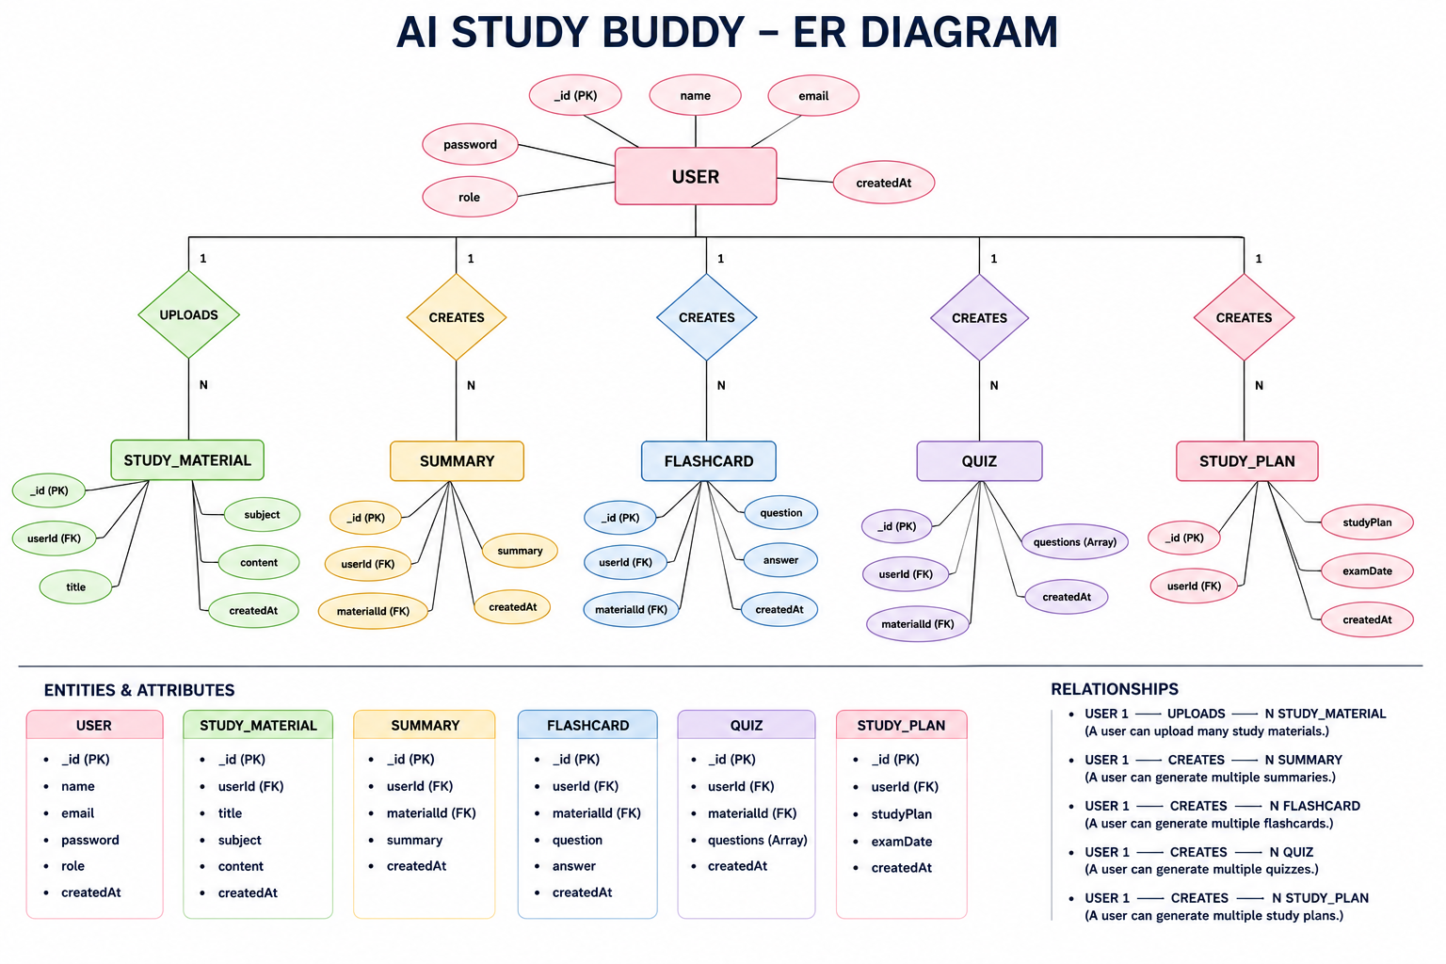

User Flow

DB Design & Roles

Collections (Linked via userId / materialId):

1. User: _id, name, email, password(hash), role
2. Material: _id, userId, title, subject, content
3. Summary: _id, userId, materialId, summary
4. Flashcard: _id, userId, materialId, question, answer
5. Quiz: _id, userId, materialId, questions[]

Relationships:

- User 1:N Material
- Material 1:1 Summary
- Material 1:N Flashcards
- Material 1:1 Quiz (with N questions)
- User 1:N Study Plans / AI Resources

Key Features:

Auth (JWT+bcrypt), Material CRUD, AI Summary/Flashcards/Quiz/StudyPlan via Gemini, RBAC, MongoDB persistence.

Roles:

- Student: Upload + Generate + Manage + Revise
- Admin: Monitor users, manage system, ensure AI & security working

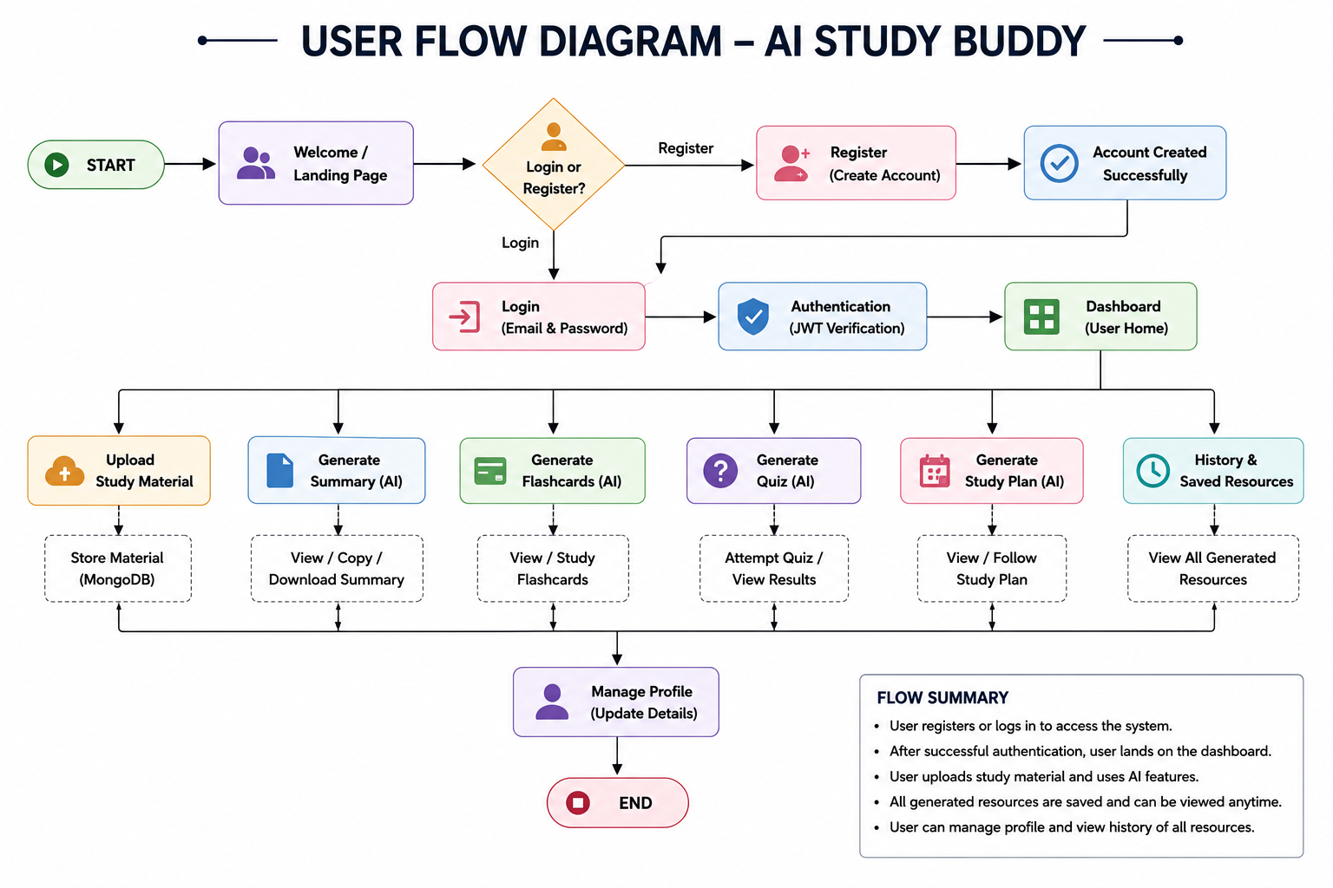

MVC Architecture Pattern

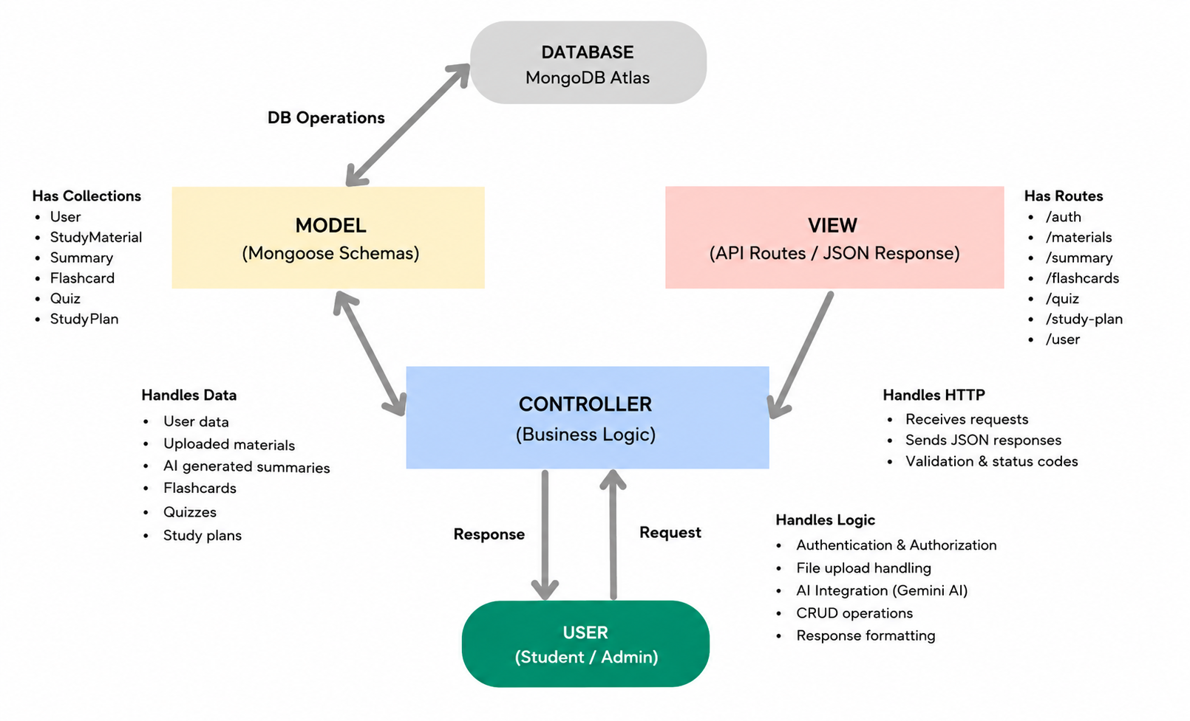
MVC Architecture:

1. Model (Data Layer):
Mongoose Schemas for User, Material, Summary, Flashcard, Quiz. Handles validation, relationships & MongoDB operations.

2. View (API Response Layer):
No HTML. Pure JSON responses via REST APIs to React client.

3. Controller (Business Logic Layer):
Core brain - receives request, checks JWT, validates input, calls Model + Gemini AI Service, sends final JSON.

Benefits:
Clean separation, easy to debug, test & scale. Add new AI feature = just add new Controller + Model.

Epic 2: Project Setup and Configuration

Creating the Project Folder

1. Create folder AI StudyBuddy → Open in VS Code
2. Init: npm init -y
3. Install deps: npm install express mongoose bcryptjs jsonwebtoken cors dotenv multer @google/genai
4. Dev tool: npm install --save-dev nodemon

Create the Following Files
- index.js
- .env
- package.json
- .gitignore

Create the Following Folder Structure
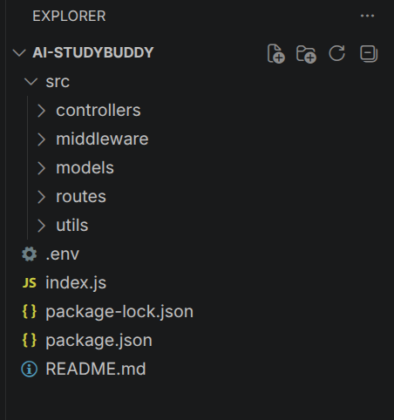

Environment Configuration

Epic 3,4,5 - Full backend

Epic 3: Backend Core

Stack: Node + Express + MongoDB - Modular (routes/controllers/middleware/models/utils)

Core Files:
- index.js: Load .env, Express setup, connect DB, start server
- db.js: Mongoose connection - DB ready aanathukku aprom tha request handle
- auth.js: JWT verify + RBAC (Student/Admin)
- gemini.js: Gemini 2.5 Flash API integration for all AI generation
- upload.js: File validation for study materials

.env:

PORT=5000
MONGO_URI=...
JWT_SECRET=...
GEMINI_API_KEY=...

Epic 4: DB Configuration

- MongoDB + Mongoose
- Collections: Users, Materials, Summaries, Flashcards, Quizzes
- User Schema: name, email(unique), password(hashed), role
- Material Schema: userId, title, subject, content

Epic 5: Execution

1. Prereq: Node + MongoDB ON
2. npm install + .env check
3. Run: npm run dev

API Flow:
1. Register -> Hash password -> Save DB
2. Login -> Check -> Generate JWT
3. Upload Material (Auth required)
4. AI Summary -> Gemini -> Save
5. AI Flashcards -> Q/A -> Save
6. AI Quiz -> MCQs -> Save
7. AI Study Plan -> Personalized schedule

